**Assignment 1:**

**Step 1:**

Create a Simple Java Project By name Calculator and inside src folder, make a package and Create 4 Classes, Each for one basic Arithmetic Operation: For Example: Add Class and define a static method by Name add(int num1, int num2){…}

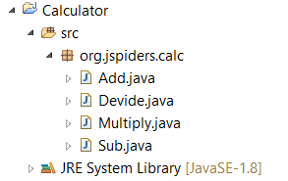

**Step 2:**

**Make a jar file form the project**

**Step 3:**

**Import the jar file into a different Java Project and Use the Classes from the jar Files for Basic Calculation Operations.**

**Assignment 2:**

**Code Convention of Java**

**Assignment 3:**

Creating 3 tables in MySQL:

1. students_info

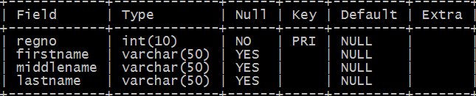

1. students_otherinfo

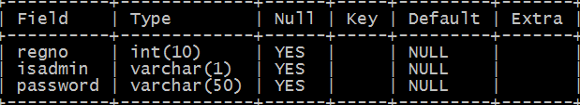

1. guardian_info

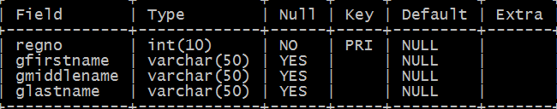

**And Inserting At least 5 data for each table.**

**Assignment** **4:**

Create 4 tables:

1. course_details

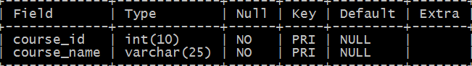

1. students_to_courses

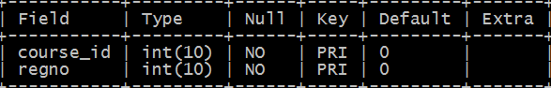

1. students_address

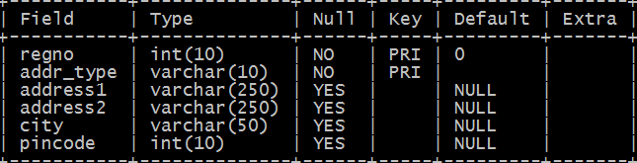

1. students_marks

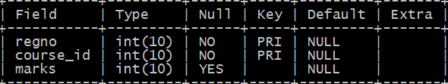

**Assignment 5:**

Find the relationships between the tables.

**Assignment 6:**

Write the MyFirstJDBC Program in eclipse and run it.

**Assignment 7:**

Write a JDBC Program to insert data into students_info.

**Assignment 8:**

Write a JDBC Program to insert data into students_otherinfo.

**Assignment 9:**

Write a JDBC Program to insert data into guardian_info.

**Assignment 10:**

Write a JDBC Program to insert data into course_details.

**Assignment 11:**

Write a JDBC Program to insert data into students_addresses.

**Assignment 12:**

Write a JDBC Program to insert data into students_marks.

**Assignment 13:**

Write a Program to Read data from a file.

Write a Program to Split a string into String arrays.

**Assignment 14:**

Write a JDBC Program to insert data into students_info by reading a file with comma separated values.

**Assignment 15:**

Write a JDBC Program to communicate with the Oracle 10g Database.

**Assignment 16:**

Write a JDBC program which will use a property file for issuing queries

and getting the driver class at run time, using Class.forName().